AZURE CONTAINER APPS:

* Build and deploy modern apps and microservices using serverless containers
* Azure Container Apps is a fully managed serverless container service that scales dynamically based on HTTP traffic or events.
* We can give the specific size as shown in azure to the container apps

Pricing:

* Azure Container Apps is billed based on per-second resource allocation and requests. **The first 180,000 vCPU-seconds, 360,000 GiB-seconds, and 2 million requests each month are free**.
* “**Beyond that, you pay for what you use on a per second basis based on the number of vCPU-s and GiB-s your applications are allocated**”.

1. Applications scale on-demand based on requests and events. Container Apps replicas are billed for active usage when they are running.
2. An application can be configured to scale to zero replicas when there are no requests or events to process. No usage charges apply when an application is scaled to zero

* You can optionally configure Container Apps with a minimum number of replicas to be always running in idle mode. When an application scales down to its minimum number of replicas, usage is charged at a reduced idle rate when a replica is inactive.
* A replica enters active mode and is charged at the active rate when it is starting up, when it is processing requests, or when its vCPU or bandwidth usage are above the active billing thresholds.

This cost will vary depends on the region.

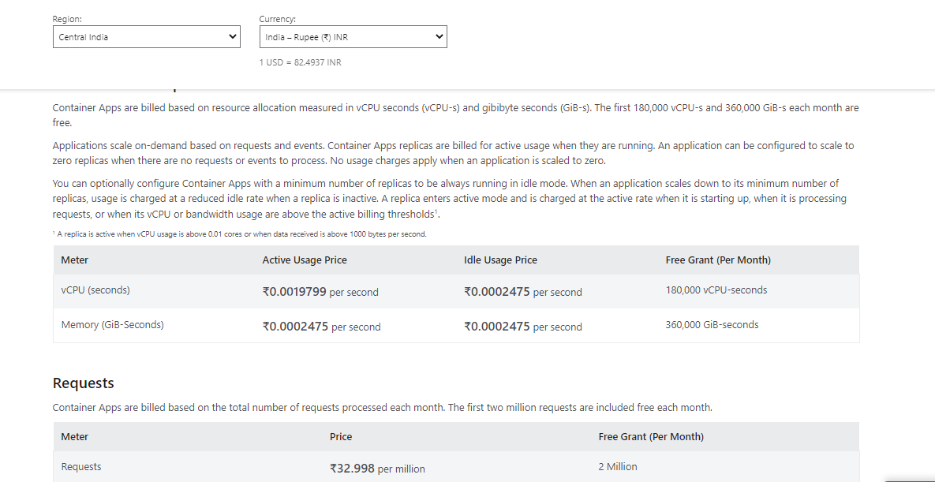

AZURE container instance

Run Docker containers on-demand in a managed, serverless Azure environment. Azure Container Instances is a solution for any scenario that can operate in isolated containers, without orchestration. Run event-driven applications, quickly deploy from your container development pipelines, and run data processing and build jobs

Azure Container Instances bill at the "container group" level which are assignments of vCPU/Memory resources that can be used by a single container or split by multiple containers. Container groups are co-scheduled containers that share the same network and node lifecycle. The price depends on the number of vCPU and GBs of memory requested for the container group. You are charged based on the vCPU request for your container group rounded up to the nearest whole number for the duration (measured in seconds) your instance is running. You are also charged for the GB request for your container group rounded up to the nearest tenths place for the duration (measured in seconds) your container group is running. There is an additional charge of ₹0.0009900 per vCPU second for Windows software duration on Windows container groups.

This cost will vary depends on the region

## Linux OS

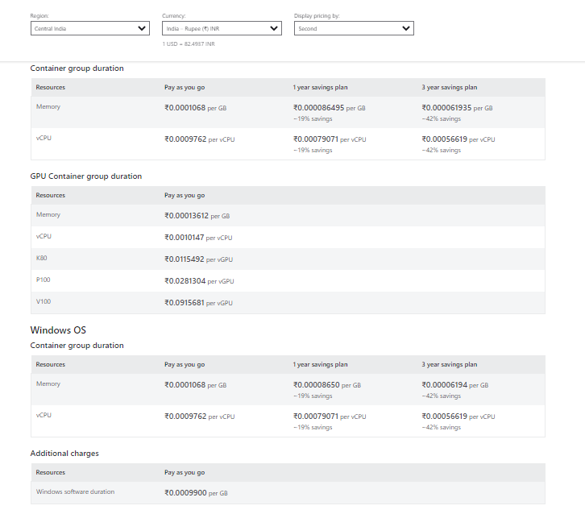

In summary

**Web App for Containers**

* Best if you have one or a few long-running containers/services that are being deployed.
* Can use a custom Docker image to run your web app on an application stack that is not already defined in Azure
* Web App for Containers offers "slots" with which you can run multiple images on the same allocated resources to help increase utilization

Creation:

<https://learn.microsoft.com/en-us/azure/container-apps/containers?source=recommendations>

**Azure Container Instances**

* "Azure Container Instances is a great solution for any scenario that can operate in isolated containers, including simple applications, task automation, and build jobs"
* A fast, light-weight and easy way of running containers Billed for the time your container is active (billing is based on seconds, cores and memory)
* Can start containers in Azure in seconds, without the need to provision and manage VMs.
* Can also work with Kubernetes through an experimental ACI to Kubernetes connector
* Currently, the fastest way to deploy containers on Azure
* Based on the Azure docs, " Azure Container Instances guarantees your application is as isolated in a container as it would be in a VM."
* . As container instances bill per time used, they do not have "slots"

Creation :

<https://learn.microsoft.com/en-us/azure/container-instances/container-instances-quickstart-portal>

* one or a few long-running containers/services that are being deployed. –container apps
* "Azure Container Instances is a great solution for any scenario that can operate in isolated containers, including simple applications, task automation, and build jobs"

Azure container app and container instance

**Note:**

Both are serverless applications

Container app will be used for three tire applications for contacting the applications

Container instance will be used is a solution for any scenario that can operate in isolated containers, without orchestration, Run event-driven applications, quickly deploy from your container development pipelines, and run data processing and build jobs